Asia-India-Muslim Warrior

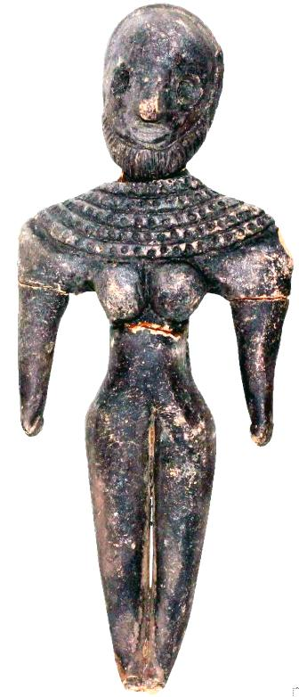

Formal Label:

Accession Number:

Date or Time Horizon:

Geographical Area:

Cultural Affiliation:

Media:

Dimensions:

Weight:

Provenance: